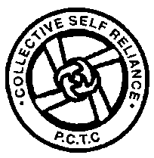

Dear Friend ,
I am happy to share with you this report due for the year 2008-2009. The Challenges were different during the course of the year both in our rehabilitation program and in the Women Development program. Change of staff at the coordination level has brought in new dimension in the program and added new insights in the planning for the year 2009-2010.

Community Based Rehabilitation Program:
We have taken up a special exercise with the parents of the children with disability (CWD) ( mentally challenged, children with Cerebral palsy and Multiple disability) in smaller groups. 341 parents along with their child were invited. This has helped the parents as well as the PCTC staff to make a quality planning for Rehabilitation intervention and greater involvement of the parents. More adolescent children are coming for Pre vocational training and the younger children are coming to the Day care Center. 3 of our cluster coordinators have left the job. We are in the process of replacing them.

Place | Day care Center | Early intervention | Parent Training | Integrated education | Pre vocational training | Other people with Disability
Kariyandal | 10 | 16 | 53 | 341 | 9 | 999
Nookambadi | 16 | 13 | 58 | 341 | 10 | 999

Rehabilitation interventions received by PWDs
S.No | Support received | Nos |  | S.No | Support received | Nos
1 | Wheel chair/Try-cycle | 5 |  | 8 | Splints and braces/Gaiters | 20 pairs
2 | Maintenance grant | 60 |  | 9 | Economic assistance-Thadco | 13
3 | Educational assistance | 51 |  | 10 | Village Rehabilitation camps | 17
4 | National ID cards | 44 |  | 11 | Special school admission | 3
5 | Surgical intervention | 3 |  | 12 | Credit assistance | 6 groups
6 | Adaptive devices | 22 |  | 13 | Mini walker | 6
7 | Bus Pass | 25 |  | 14 | Other assistance | 30

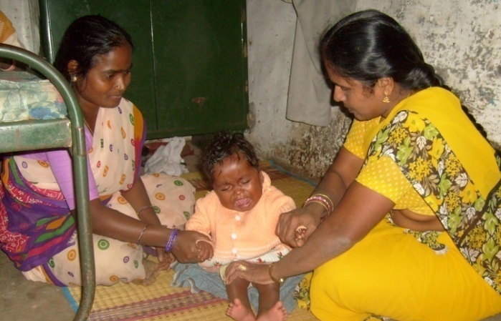
Parents of Children with disability had two coordination meetings to get to know the effectiveness of the Parent training Program and for further planning. It is always a constant challenge to work with the differently able people bearing in mind that every- thing is possible with them.

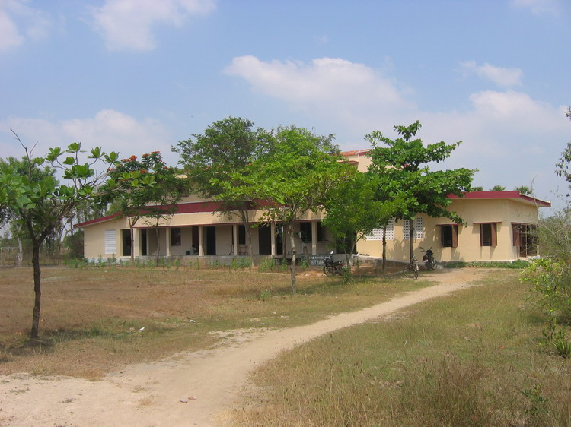
Regional center at Nookambadi-15 Kms from Kariyandal campus- to make accessible our services for rehabilitation and other development programs for the people closer to that area. One more floor of 3000 Sq. feet was added this year to house the pre vocational training unit
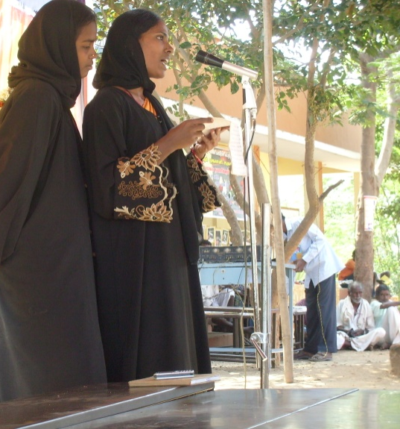
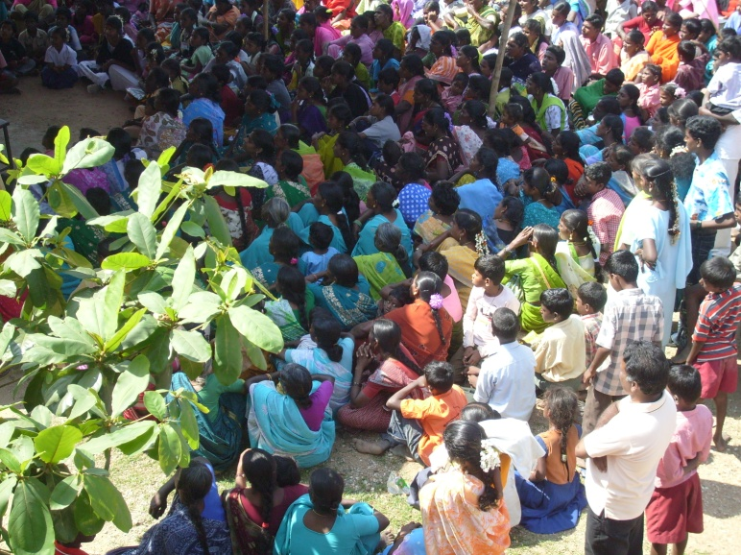
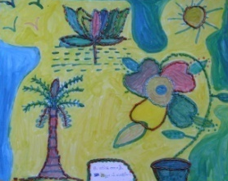
Women Development Program:
Members of the Women self help groups performing during People’s festival 2008
As on date we have 715 groups inclusive of the 27 new groups formed during the year. 60 groups have received a credit assistance of Rs:60,000 each. One fourth of the total number of groups got disintegrated as there are no clear guidelines regarding the area of operation for the NGOs. People easily get attracted to the NGOs, where there are no systems. This has hampered the concept of alternate banking through self help groups. A number of individuals in the self help groups are doing well with an economic activity, but there are no group activities. Most of groups stick to rearing cows as they can easily market milk. Our effort to bring in new trades have failed. The group insurance for life coverage for the members up to 60 years is gradually picking up and now there are 1880 members including 654 new entrants. We have settled 6 death claims during the reporting period. HDFC bank has given a credit assistance of 5.47 million to 29 groups apart from other nationalized banks in the area- which are regularly giving credit assistance to the existing groups.
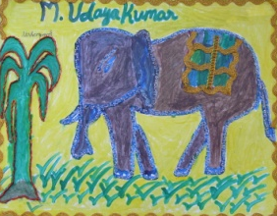
All the new groups had their training in Book keeping and management of Self help groups and their active participation in village development.
Additional infrastructure:
The new 1800 Sq. Feet built up area of first floor at Nookambadi gives more space for the children in the adolescent group. All the temporary roof are removed and the whole building has concreted roof and bears colorful look. Compound wall on the northern side of the Kariyandal campus is completed. A new toilet block is nearing completion. Rectification work in the electrical installations had been completed which was due to the damage caused by the lightening..
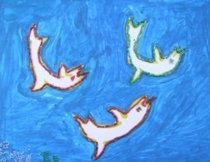
Community Health Program:
6 People living with HIV and AIDS were given regular care and support. 108 Children with Disability had monthly check up and treatment. People have gradually switched from the traditional system to the allopathic system. Our effort to revive the traditional system among the people brings in very slow response from people, they prefer to have faster relief than eradication of the cause and less side effects. We continue to work with the school going children- as they being the future stake holders, if they are convinced they can bring about a change in the community. The impact was very interesting. Many of the children in Thulir program can now identify as many as 30 herbs and their uses. Some of them have planted herbs in their kitchen garden. In one village they have also developed a community herbal garden. In India many people affected by Diabetics.. even in the rural areas the incidence is more. We have designed a special program for the care of people affected by diabetics. Exploring possibilities to conduct village camps to educate people on the preventive measures and on management of this sickness.
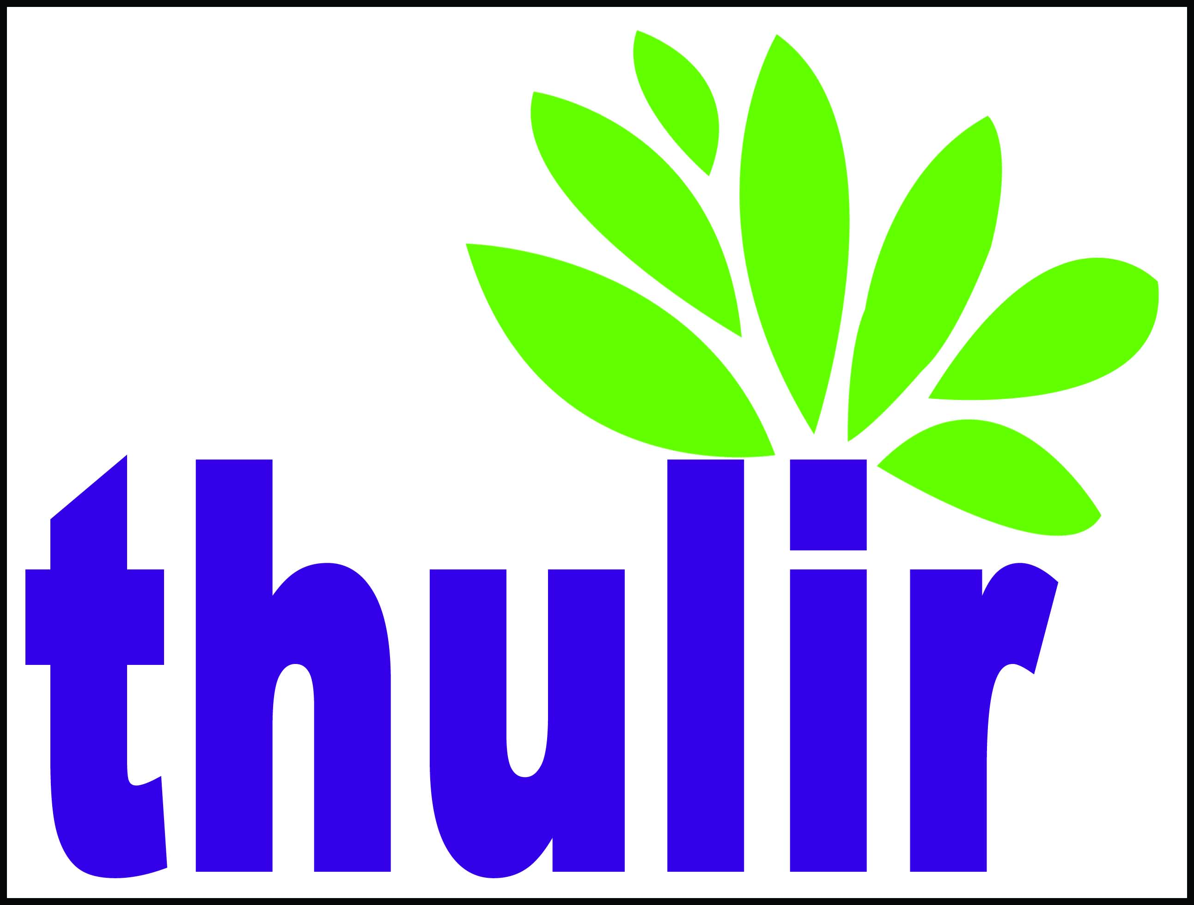
Thulir-Students’ Clubs:
Financial Report for the year 2008-2009( year ended on 31st March)
Receipts |  |  | Payments
Head | Amount in Rupeess | % | Head | Amount in Rupees | %
Opening Balance | 2,693,974 | 31.25 | Core program | 1,400,020 | 16.24
Foreign Donations | 206,895 | 2.40 | Rehabilitaiton | 1,016,014 | 11.79
Foreign grants | 799,400 | 9.27 | Women Develop. | 163,675 | 1.90
Local Donation | 681,186 | 7.90 | Community health | 243,679 | 2.83
Local grants | 484,654 | 5.62 | Organic Farming | 58,419 | 0.68
Campus facilities | 1,378,012 | 15.99 | Rehab.Workshop | 202,343 | 2.35
Int. from Investments. | 2,083,668 | 24.17 | Repairs & Maint. | 253,937 | 2.95
Realization of funds | 250,000 | 2.90 | Computer school | 44,325 | 0.51
Bank Interest | 42,448 | 0.49 | Program. Maint | 254,920 | 2.96
 |  |  | Acquisition of assets | 2,786,507 | 32.33
 |  |  | Closing balance | 2,196,398 | 25.48
 | 8,620,237 | 100.00 |  | 8,620,237 | 100.00
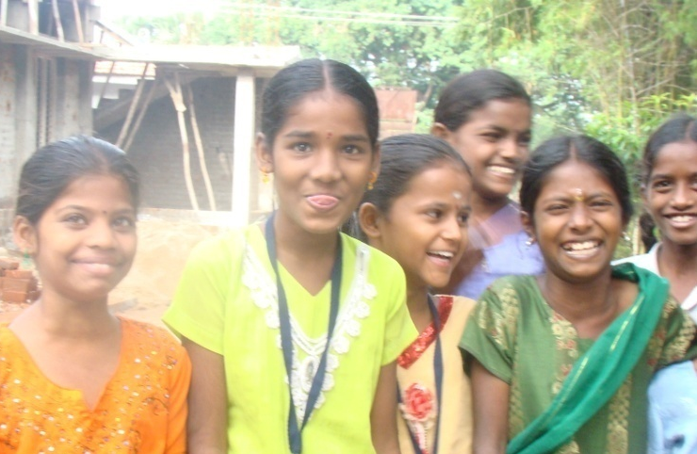
We have 4 student clubs in 4 villages. Before we initiate the student clubs, we ensure fully that the self help groups and the village elected representative actively participate in the program. Giving a Place to conduct evening classes and electricity is one such participation by the village people. We are overwhelmed by the participation of the children and active participation in the different camps conducted for them on Leadership, theatre skills, and on arts and crafts. 120 children are enrolled during the reporting period. Three camps were conducted for them during holidays on Self development skills, arts and crafts. As we consider them the stake holders of the future, a continuous on going training program is planned for them . this training is done during the holidays. The special emphasis on the present world scenario of the planet-and –the eco system, the medical system, the food production industry-with special reference to agriculture- the kind disaster it is making to the planet and the people. The importance of reviving the local traditional knowledge so that they can have the responsibility to pass a cleaner sustainable environment to the next generation. They are also involved in their respective villages to be active partners of PCTC in developing localized program is their respective village , like community herbal gardens and home remedies, organic farming practices.
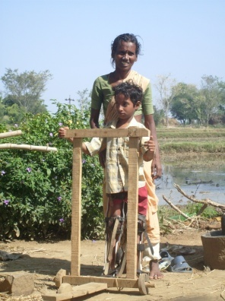
As we conclude this report,
we look forward to a new year and the following would be the thrust areas.
- Identification of Children with disability immediately after birth and starting early intervention program.
Home based intervention
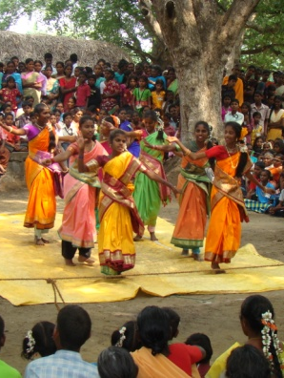
- Inducting as many Adolescent boys and girls with disability as possible in the pre-vocational training and sustaining them.
- Strengthening the pre vocational training units at Kariyandal and Nookambadi.
- Palm leaf training unit to be enlarged with more number of participants.
- In-service training to the staff in the Rehabilitation unit for effective management of Children with disability.
- Initiating Thulir student movement in new villages regular training on sustainable environment.
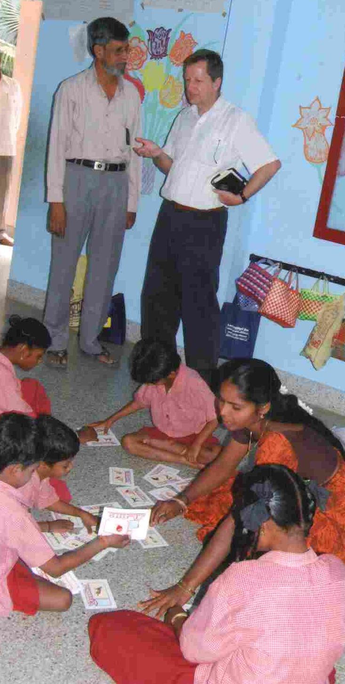
- Preparatory work to start Community college to consolidate our training efforts and formalize the courses we offer.
People’s Festival
- Motivating youth and women to start small enterprise.
- Motivating local farmers to join organic farmers Club.
- New Building for Pre vocational Training unit
- Re organizing the Women Development program.
We thank you for all your support and inspiration to keep things alive at our end. We will continue explore possibilities and commit ourselves to make a dent to have a breakthrough where ever we could not achieve in the past.
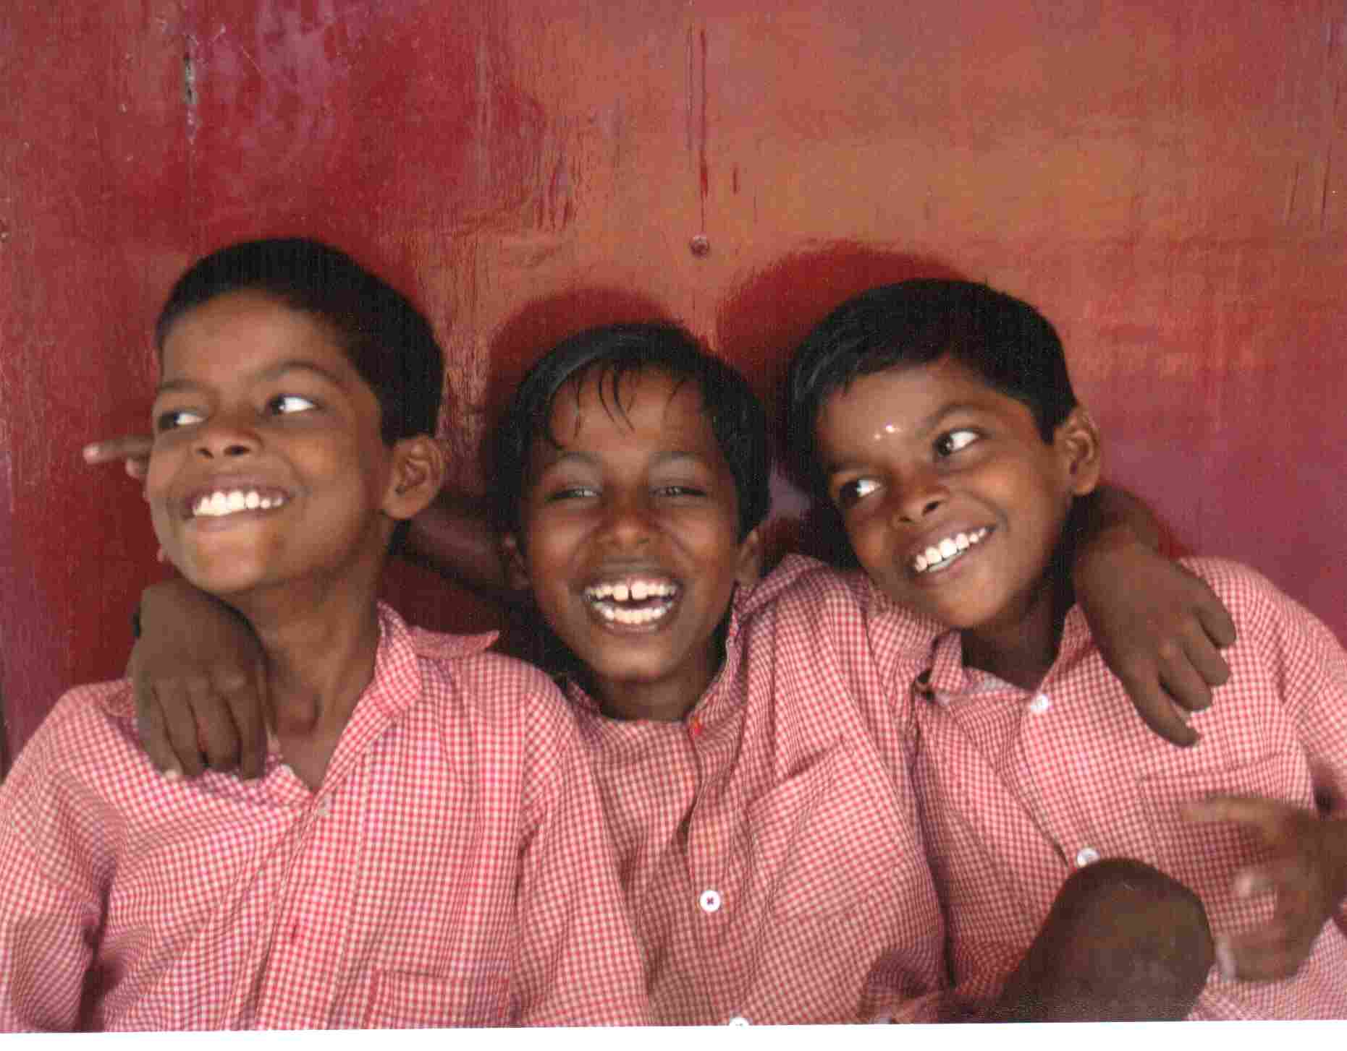

World Bank
visit to Day care center
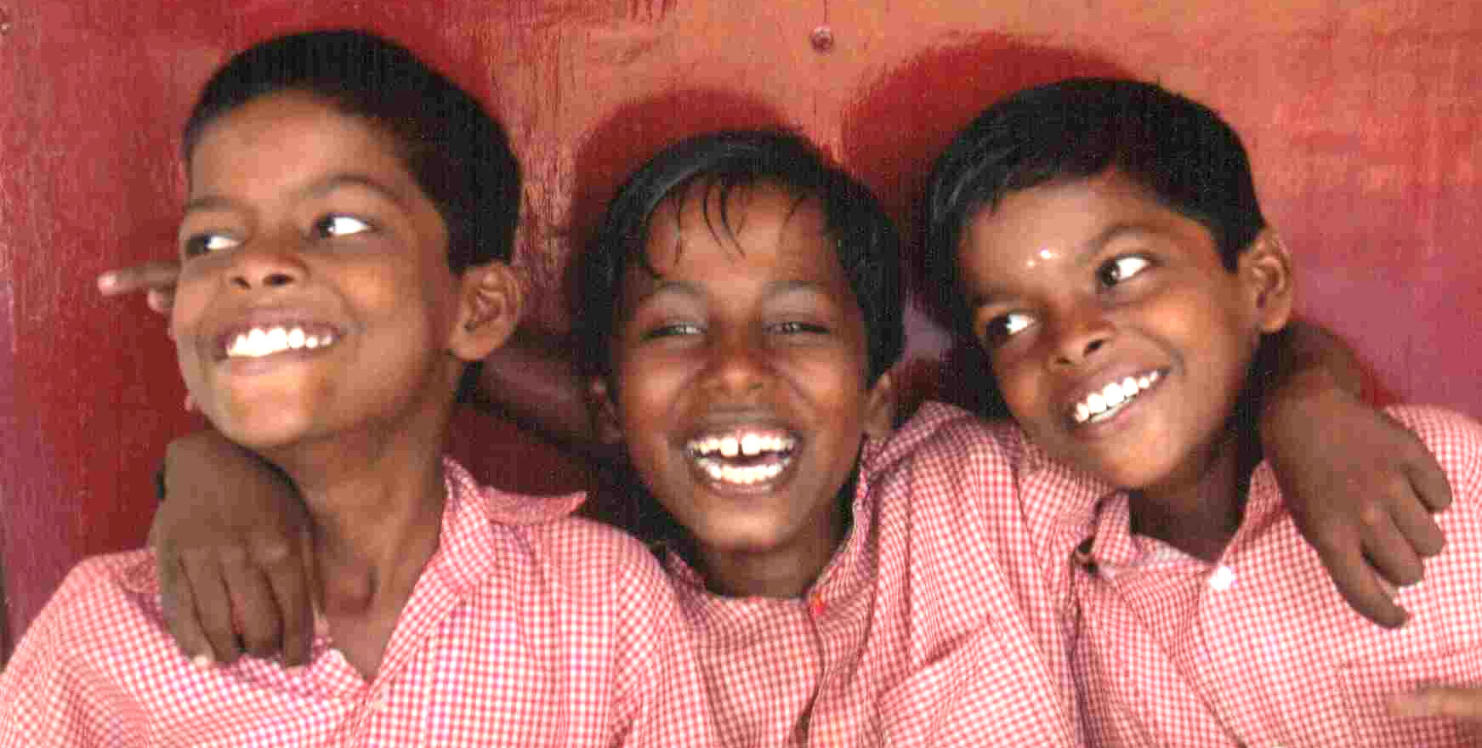
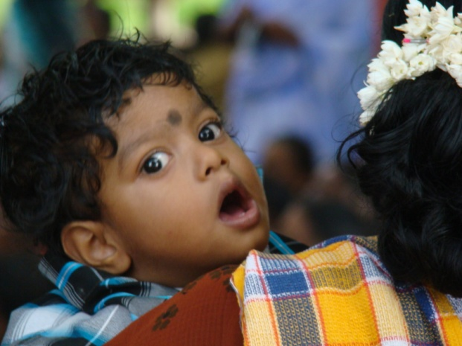
Xavier Mariadoss, all the staff and people of the area and children

